**McDonald's Menu Nutritional Analysis – Project**

1. **Data Preprocessing:**

* **Load and inspect the dataset.**

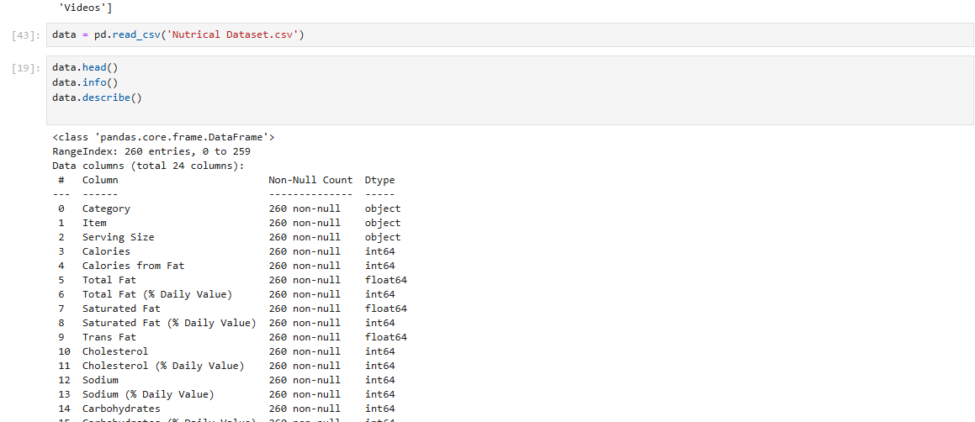

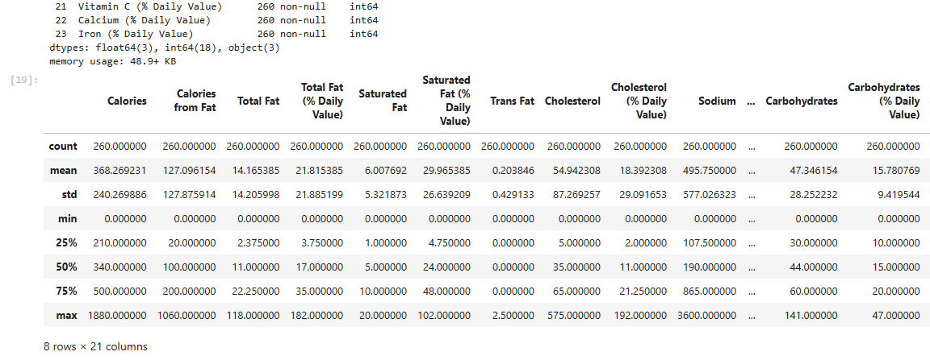

* **Handle missing values and data cleaning if necessary.**

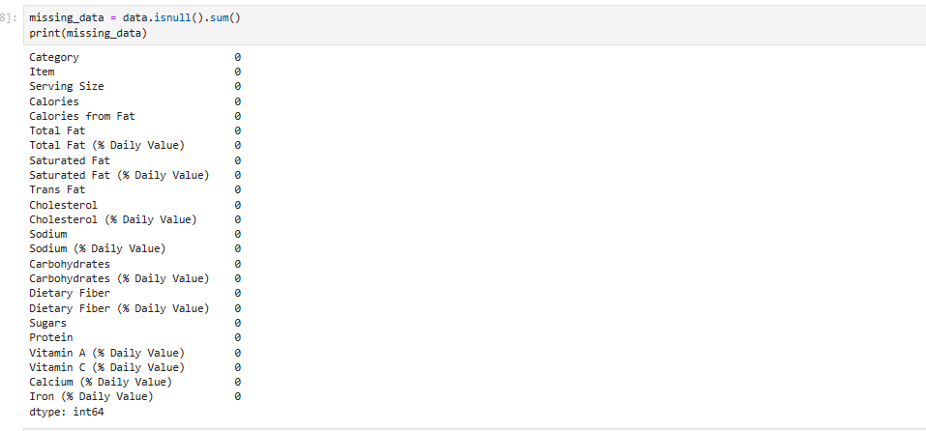

**2- Exploratory Data Analysis (EDA):**

* **Analyze the distribution of calorie counts across menu items.**

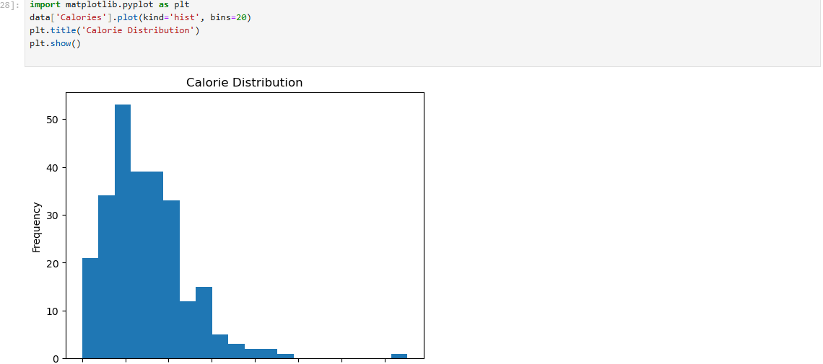

* **Identify trends and patterns in the dataset.**

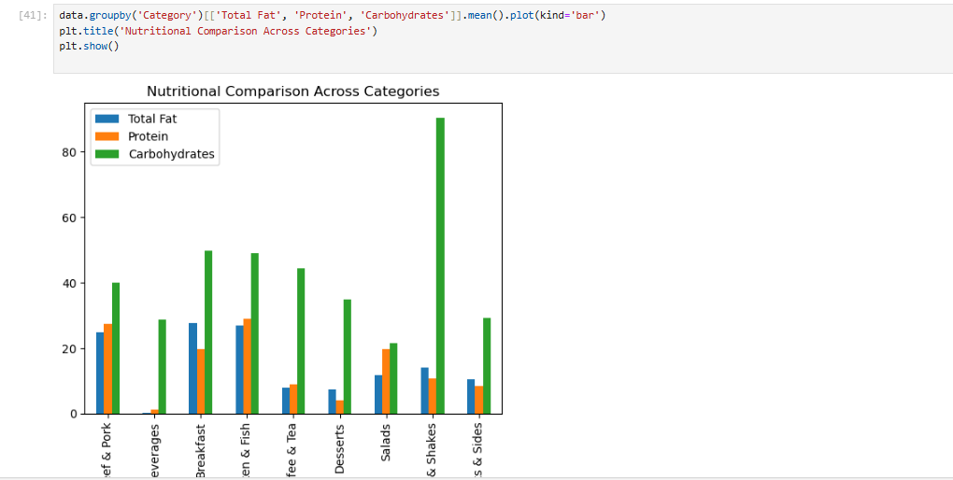

* **Explore the nutritional content (e.g., fat, protein, carbohydrates) of different items**.

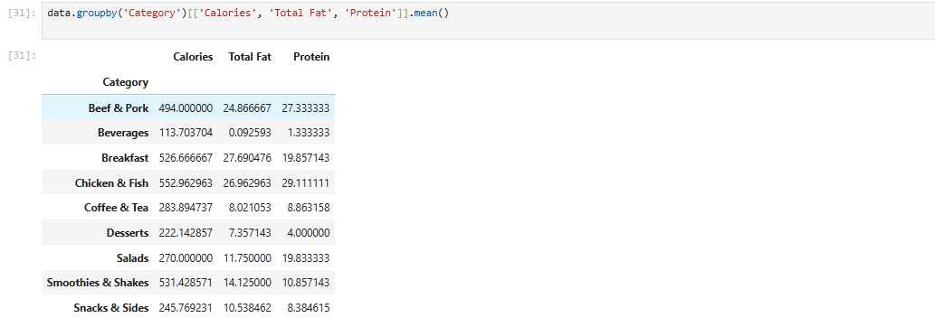

**3 - Data Visualization:**

* **Create bar charts, histograms, and box plots to visualize calorie distribution and nutritional content.**

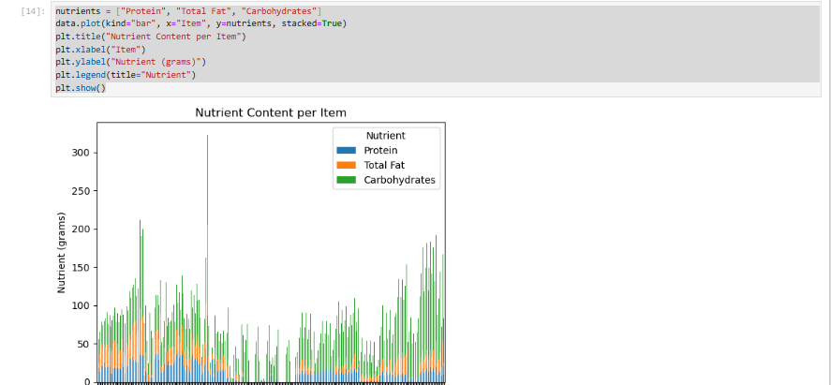

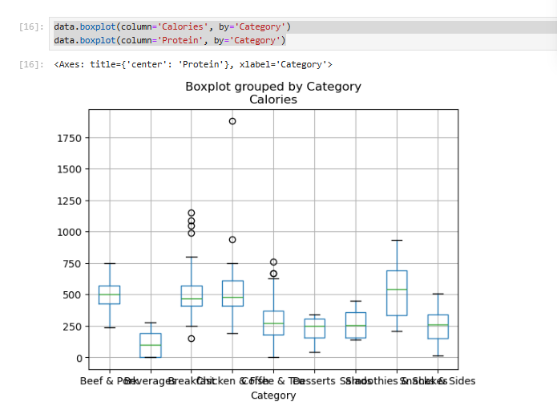

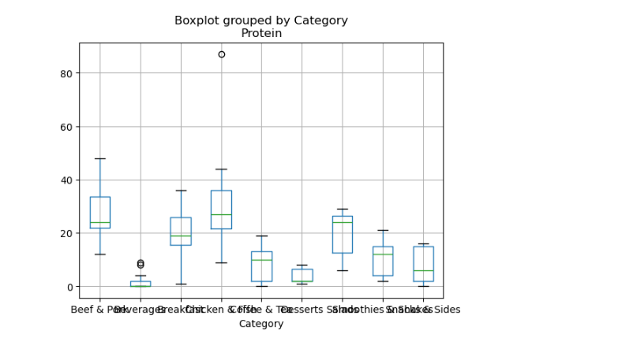

* **Compare nutritional characteristics of different food categories (e.g., burgers, salads, desserts).**



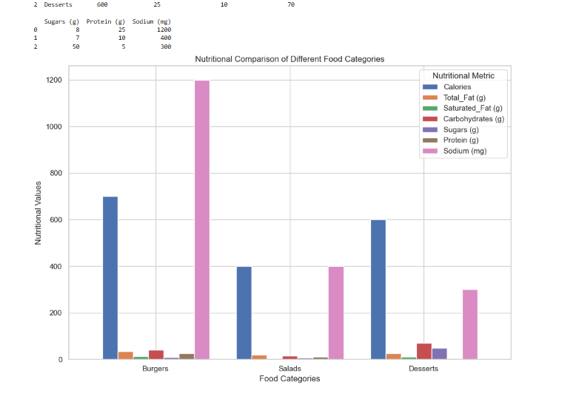

**Nutrition-Based Insights:**

* **Identify menu items with the highest and lowest calorie counts.**

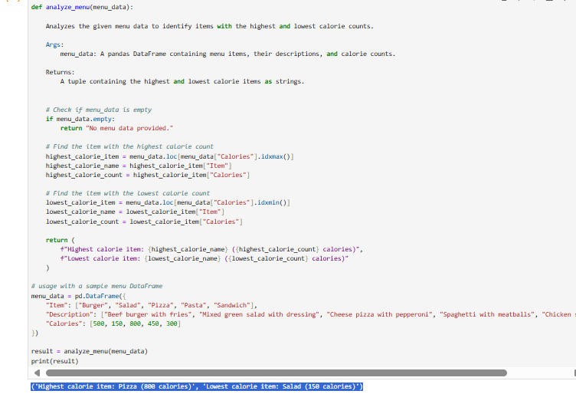

**Ans - ('Highest calorie item: Pizza (800 calories)' , 'Lowest calorie item: Salad (150 calories)')**

* Determine the average nutritional content of popular menu categories.

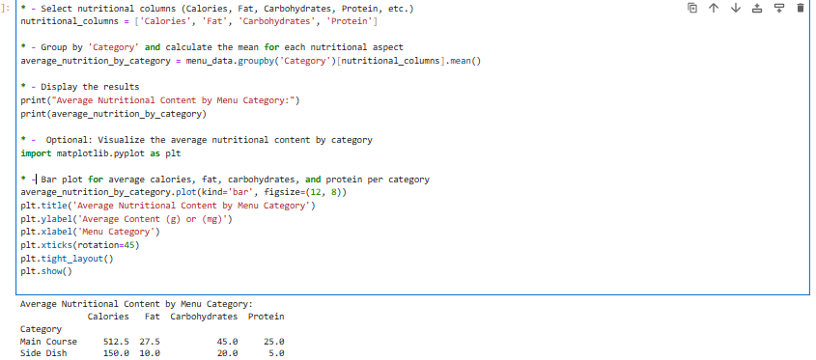

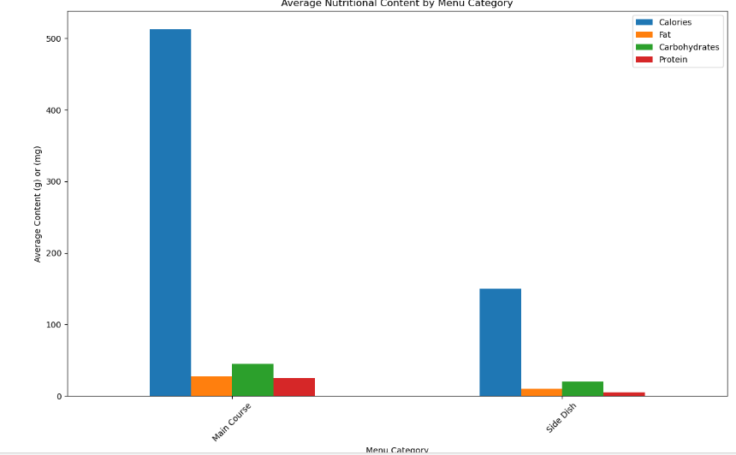

**5 - Documentation and Reporting:**

* **Summarize the findings and insights from the analysis.**
* **Explain how the nutritional analysis could benefit McDonald's customers and the organization.**

**Findings and Insights from Nutritional Analysis of McDonald's Menu Items:**

1. **Calorie Content**:
   * Menu items vary widely in calories, with breakfast items like the **Sausage McMuffin with Egg** containing up to **450 calories**, while lighter options like the **Egg White Delight** have only **250 calories**.
   * **Calories from fat** contribute a significant portion in many items, particularly in sausage-based meals.
2. **Fat and Saturated Fat**:
   * High-fat content is prevalent in breakfast sandwiches, with up to **28g of total fat** and **52%** of the daily value in saturated fat for some items.
   * Trans fats are relatively low, with many items containing **0g trans fat**.
3. **Carbohydrates and Sugars**:
   * Carbohydrate content remains consistent across many items, around **30g** per serving, with **3g** of sugars in lighter breakfast choices like the **Egg McMuffin**.
   * Fiber content is modest, contributing about **17% of daily value** in most items.
4. **Protein and Micronutrients**:
   * Items such as the **Sausage McMuffin with Egg** provide higher protein levels, up to **21g**, beneficial for maintaining a balanced diet.
   * Key nutrients like **calcium (25-30% daily value)** and **iron (10-15% daily value)** are well-represented, particularly in cheese and meat-based products.

**Benefits to McDonald's Customers and the Organization:**

1. **For Customers**:
   * **Informed Food Choices**: Nutritional transparency helps health-conscious consumers choose lower-calorie, lower-fat options, such as the **Egg White Delight** over higher-calorie meals like the **Sausage McMuffin with Egg**.
   * **Nutritional Balance**: Customers can adjust their meals based on individual needs, opting for high-protein, low-fat choices for a more balanced diet.
2. **For McDonald's**:
   * **Healthier Menu Options**: This analysis can guide McDonald's to promote healthier items and modify existing ones, helping them cater to a more health-conscious audience.
   * **Customer Loyalty and Corporate Image**: Enhancing transparency about nutritional information can foster trust and customer loyalty, positioning McDonald's as a company that cares about its customers' well-being. ​